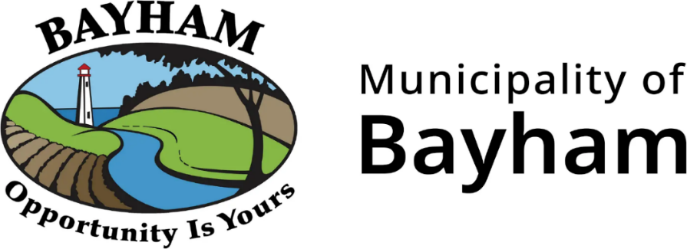

Consulting Services
Architectural Design & Engineering
Port Burwell Main Beach Washrooms

REQUEST FOR PROPOSAL
No. MB-26-03

The Municipality is inviting Proposals from consulting firms to undertake the Architectural Design and Engineering Services for the Port Burwell Main Beach Washroom Project.

To obtain RFP documents, please visit https://elgincounty.bidsandtenders.ca

If you have any questions regarding this RFP, please contact Purchasing Services at 519-631-1460 ext. 7129.

