

Short-Term
Rental
Licensing

APPLICATION GUIDE
for new and existing
operators


Introduction

On December 4, 2023, City Council passed By-law No. 2023-115 respecting short-term rental licensing. In accordance with the Short-Term Rental Licensing By-law, all short-term rentals must be licensed with the City of Owen Sound.
for new and existing
operators

This guide provides information to assist short-term rental licence applicants with the application process.
In this guide, short-term rentals that are in the operator’s primary residence are PR-STRs. Short-term rentals located in the Downtown Core (zoned C1) that may not be the operator’s primary residence are C1-STRs. Bed & Breakfasts (B&Bs) are short-term rentals in a residential zoned area, that are located in the operator’s primary residence and provide at least one meal with a stay.
Contact | If you have questions after reading this guide, please contact the City’s STR Licensing Coordinator at:  Email: str@owensound.ca Phone: 519-376-4440 ext. 1257
Summary
HIGHLIGHTS OF THE SHORT-TERM RENTAL LICENSING PROGRAM
This section provides a summary of the short-term rental licensing program. It is not intended to replace the Short-Term Rental Licensing By-law. It is the applicant's responsibility to read and understand the by-law. The by-law can be found at OwenSound.ca/STR.
Application, Licence, and Licensing Fees
- There is an annual licensing application and application fee as part of the program.
- The application can be accessed online at OwenSound.ca/STR on the Applicants & Operators page. The application can be submitted at any time of year and, once approved, the licence is valid for one (1) year.
- The fee payment is non-refundable and is due when the application is submitted to the City. The application fee is $500.00 for PR-STRs & B&Bs, and is $750.00 for C1-STRs .
- When final approval is provided, a licence will be issued. The licence must be displayed in a prominent place at the short-term rental along with the fire safety plan.
Operators
- Operators of PR-STRs and B&Bs must be at least 18 years of age and must be individuals and cannot be corporations, partnerships or any other legal entity.
- Operators of C1 STRs may be corporations, partnerships or any other legal entity but must have a representative contact that is at least 18 years of age.
Principal Residence
- PR-STRs in Owen Sound, outside of the Downtown Core, must be located at the principal residence of the operator. All B&Bs must be the operator’s principal residence.
- Principal residence means the dwelling owned or rented by the operator, either alone or jointly with others, where the operator is ordinarily resident, and which is shown as the principal residence on the operator’s income tax filing or other government records.
Operating Days
- A PR-STR may operate for a maximum of 240 days per year.
- C1-STRs and B&Bs may operate 365 days a year.
Permissions
- Where applicable, applicants must demonstrate that they have permission to operate a short-term rental from their condominium corporation and/or landlord.
Insurance
- Applicants of PR-STRs and C1-STRs must provide a certificate of insurance that includes:
  - a liability limit of no less than two million dollars ($2,000,000.00) per occurrence for property damage and bodily injury; and
  - a statement that a short-term rental is being operated on the premises.
- Certificates of insurance for Bed & Breakfasts must also include:
  - the City of Owen Sound as an additional insured with respect to the operation of a short-term rental; and
  - an endorsement that the City will be provided at least 30 days’ notice in writing of any cancellation or material variation to the policy.
Occupancy Limits
- PR-STRs and C1-STRs must comply with set occupancy limits, which are based on two (2) persons per legal bedroom, plus two (2) additional persons (e.g. in common areas) up to a maximum of eight (8) people. This limit includes members of the operator’s household present during the rental period.
For example: a short-term rental with two (2) legal bedrooms has a maximum occupancy of six (6) people. 2 bedrooms x 2 people per bedroom = 4 people + 2 people in the common areas = maximum of 6 people.
A short-term rental with four (4) legal bedrooms has a maximum occupancy of eight (8) people: 4 bedrooms x 2 people per bedroom + 2 people in the common areas = 10 which is greater than the maximum of 8 people so the occupancy is reduced to the maximum 8 persons.
Note: Bed & Breakfasts do not have the 8-occupant restriction and are limited to 2 persons per legal bedroom plus the operators.
Multiple Groups
- Multiple groups are not allowed to be booked simultaneously in a short-term rental.
- This requirement does not apply to Bed & Breakfasts.
Parking
- Parking for short-term rentals can be on-site at the location of the short-term rental and off-site in City parking lots or on-street parking stalls.
- The number of parking spaces available on-site at the short-term rental will be determined during the application process. Parking spaces must be hard-surfaced and measure at least 2.65 m by 6 m. Vehicles that cannot be accommodated at the short-term rental will need to legally park elsewhere.
- Street parking is available during the day and overnight from April 1 – November 30 in certain areas. If your visitors’ parking needs cannot be accommodated on-site or on the street, parking passes can be purchased for municipal lots.
- Between December 1 and March 31, vehicles may not park on the street between 1:00 a.m. and 7:00 a.m. or they may be fined and possibly towed.
- Parking passes and overnight parking passes for winter parking can be purchased at City Hall or the Bus Terminal during regular business hours. It is recommended that if your visitors require a parking pass, you ensure they are aware of the times and locations of overnight winter lots and provide a pass for their use.
Garbage & Recycling
- All short-term rentals must be kept in a clean and sanitary condition with adequate measures for the storage and disposal of waste. These can include a self-enclosed building, structure, or container that is located outside the short-term rental and that is of sufficient size to store the waste generated at the short-term rental.
- Garbage and recycling bins are to be placed at the curb by 7:00 a.m. on collection day. All garbage must have a City bag tag. OwenSound.ca/Waste.
- Operators who request that visitors put garbage and/or recycling out at the curb are still responsible to ensure the garbage is set out at the correct day and time, has the required tags applied, and any uncollected items are removed promptly.
Fire Safety
- Short-term rental operators must provide a fire safety plan as part of the licence application. This plan includes a simple layout of the interior of the short-term rental with locations of smoke alarms, carbon monoxide alarms, fire extinguishers, and exits.
- It is the operator’s responsibility to ensure that smoke alarms, carbon monoxide alarms, and fire extinguishers are in good working order and that any deficiencies are corrected immediately if observed while the STR is rented.
- The fire safety plan submitted with the application will be reviewed and laminated for you and must be displayed in a prominent location within the short-term rental, such as at a primary entrance/exit.
Electrical Safety
- Your application must include a letter from a qualified, insured, and licensed electrician that the short-term rental conforms to the Electrical Safety Code.
- Renewal applications do not require reinspection if no work has been completed. Where work was done the ESA Letter of Acceptance is required with the renewal application.
Water Quality
- If the short-term rental is on a well, the applicant must provide proof of well water testing within the previous year that confirms the absence of bacterial contamination. This can be obtained from Grey Bruce Public Health by picking up a water sample collection kit at Grey Bruce Public Heath 101 17th St East, Owen Sound between 8:30am to 4:30pm Monday to Friday, obtaining a sample from your well and dropping it off within 48 hours of collection.
- PublicHealthGreyBruce.on.ca/Your-Environment/Safe-Water/PrivateDrinking-Water.
Septic System Maintenance
- If the short-term rental is on a septic system, the applicant must include proof of septic maintenance, inspections, and pump-out servicing within the last three years. An invoice or letter from a licensed septic servicing company that shows the date pump out and an inspection was performed is required.
Enforcement
- Enforcement typically begins with education on the first visit by an officer to a short-term rental, followed by penalties on subsequent visits. An officer includes any person authorized by the City to enforce by-laws, including by-law enforcement officers and police officers.
- A short-term rental licence will be revoked where the short-term rental has three or more violations in a six-month period or four or more violations in a calendar year. A violation means that an officer has attended the property, determined that there has been a contravention of a law or by-law, and issued a ticket, order or other penalty.
- Tickets may be issued to both occupants and operators of short-term rentals for violations.
Visitor’s Code of Conduct
- Every group of short-term renters, called visitors, must be provided with a Visitor’s Code of Conduct.
- The Visitor’s Code of Conduct is provided with your license and sets out the roles and responsibilities of visitors in short-term rentals. The visitor responsible for booking the short-term rental must confirm receipt of a copy of the code and this confirmation must be kept by the operator for one (1) year.
Visitor’s Information Package
- Visitors must also be provided the information package. The information package is created by the City and contains instructions on how to access the short-term rental program information, by-laws, and certain services within the City (9-1-1 information, name and address of nearest hospital, non-emergency contacts, etc.).
Online Registry
- The City maintains an online registry of the licensed STRs in the City. Once an application is approved and a licence is issued, the address, license number and expiry of the property is added to the registry.
MAT Registration
- Once an application is complete and has been reviewed the City will send the STR and Operators contact information to the Ontario Restaurant Hotel and Motel Association (ORHMA) to begin the MAT registration process. You are required to enter your rental information each month and remit collected MAT within 30 days of the end of each quarter.
Keeping Visitors safe in Grey & Bruce
- Grey and Bruce County, in partnership with Owen Sound Police, is committed to raising awareness about human trafficking and how, as operators, you can help ensure the safety of visitors. When your licence is issued, we will include an information sheet about what protections are in place to prevent human trafficking. As an operator, we ask that you review the information linked below and report any concerns to the Owen Sound Police. URL Link

Application Process
Step 1: | Complete the Application Form
Step 2: | Payment of Application Fee
Step 3: | Review by City staff
Step 4: | MAT Registration with ORHMA
Step 5: | Approval and License Issuance
Step 6: | Short-Term Rental Startup, Advertising and Operation


Step 1: Complete the Short-Term Rental Licensing Application Form
The application and renewal form can be found online at OwenSound.ca/STR on the Applicant & Operators page. For an application to be complete the applicant will need to provide the following items:
- Proof of Ownership or Letter of Authorization from the owner.
- Verification of Primary Residence
- Verification of Operator’s age
- Confirmation of Insurance
- Photo(s) of the front of the Short-Term Rental, and the entrance if not at the front
- Simple plan showing the property, building and parking spaces on-site or on the road
- Simple layout of all levels of the Short-Term Rental that Visitors have access to showing the location of exits, operable windows, smoke/co alarms and fire extinguisher
- Letter from a licensed electrician that the Short-Term Rental has been inspected and generally conforms to the Electrical Safety Code and is safe.
- Any additional document as shown in the Application Checklist that may apply.
The applicant, if using the printable forms, will need to sign the Indemnity Agreement and Declaration at the end of the form. If a witness is not readily available City staff can witness your signing at City Hall when submitting.
Note: These documents may vary from applicant to applicant and are outlined in the Application Checklist included in the Sample Application Package.
Note: Any drawings, plans or layouts required for the application (i.e. site plan, fire safety plan, parking management plan) can be done by the applicant using a computer program or drawn by hand, provided they are legible and all required information is shown.

Step 2: Payment of Application or Renewal Fee
The application and renewal fee of $500 for PR-STRs & B&Bs or $750 for C1-STRs must be paid at the time of application and is non-refundable.
It can be paid with cash, cheque or debit in person at City Hall or by mailing a cheque with your application to the STR Coordinator at City Hall 808 2nd Ave East, Owen Sound, ON, N4K 2H4. Cheques should be made payable to the City of Owen Sound.
DOWNTOWN CORE MAP

Step 3: Review and inspection by City staff
Once your application is complete and the application fee has been paid your application package will be reviewed by staff. Staff may reach out with additional questions or document requests and will contact you to coordinate the inspection.
Important: If the application is incomplete and staff have contacted you to supply missing item(s) you have thirty (30) days to submit the items or the application file will be closed. In this circumstance, the applicant will need to apply again, including payment of the application fee. Fees previously paid will not be refunded. If additional time is required it must be approved by the STR Coordinator,.
Step 4: Municipal Accommodation Tax Registration with ORHMA
Once an application has been reviewed by staff, the applicant will be contacted for the inspection of the Short-Term Rental and the City’s STR Coordinator will submit the applicant’s contact details to the Ontario Restaurant Hotel and Motel Association to begin the Municipal Accommodation Tax (MAT) registration. ORHMA will contact the applicant to set up an account to submit information regarding rentals at the end of each month and remit collected MAT within 30days of the end of every quarter.
Step 5: Approval and Licence Issuance
Once all the above steps are complete and the licence has been approved staff will laminate your Short-Term Licence, fire safety plan, and the human trafficking information sheet and email you with the Visitors Guide and Visitors Code of Conduct. This licence permits the applicant to advertise and operate the short-term rental at the address noted for a period of one year and will require renewal on or before the expiry date of the licence.
The licence, fire safety plan, and human trafficking information sheet must be displayed in a prominent location at the short-term rental such as at a primary entrance/exit.

Step 6: Short-Term Rental Startup, Advertisement and Operation
After the applicant has received picked up their license, they may advertise and rent their registered location as a short-term rental.
As you receive bookings you will need to:
- Provide visitors copies or a link to your STRs Visitor’s Code of Conduct and the Visitor’s Information Package
- Retain a copy of the signed Visitor’s Code of Conduct form (the last page) for one (1) year from the rental date; and
- Record your guest’s information in the Visitor’s Logbook or other registry of your choice that record the number of Visitors, date and duration of their visit, and the nightly rate charged before fees, taxes, or MAT.
Sample Application Package


The following pages contain sample documents that are required as part of the short-term rental licensing application package. Application submissions, including supporting documents, will vary from applicant to applicant. Therefore, the following sample application package is to be used for reference only.
If you have questions while completing your application, please contact the City’s STR Licensing Coordinator at:
Email: STR@owensound.ca
Phone: 519-376-4440 ext. 1257
This package contains:
- Application Checklist
- Sample Tax Bill
- Sample Site Plan
- Sample Picture of Front of STR
- Sample Government Issued ID
- Sample Proof of Primary Residence
- Sample Parking Management Plan
- Sample Fire Safety Plan

Application Checklist - Part 1
All applicants must submit the following supporting documents with a Short-Term Rental Licence Application Form. Please use the check boxes below to confirm that you have included everything with your application form:

Ownership – provide one of the following two documents:
- Proof of Ownership of the property on which the Short-Term Rental (Accepted documents may include copy of Property Tax Bill or Transfer/Deed.) or
- Owner’s Authorization Form (if Applicant is not the Owner)
Proof of Primary Residence of the Applicant.
- Accepted documents may include copy of Driver’s Licence, Income Tax forms or returns.
Verification of 18+ Age of the Operator
- Accepted documents may include copy of Driver’s Licence or other valid Government issued ID.
Proof of Insurance that:
- has a liability limit of no less than 2 million dollars with coverage for, but not limited to, bodily injury and property damage per incident; and
- identifies that a short-term rental is being operated on the property.
For Bed and Breakfasts, proof of insurance that also:
- names the City as an additional insured with respects to the operation of the Short-Term Rental; and
- endorses that the City will be given 30 days written notice of any cancellation or material variation of the policy.
Photo of Front of Dwelling (and Front Entry of the short-term rental if different)
Site Plan showing house and accessory structures, setbacks to lot lines, dimensions and garbage location (see sample).
Parking Management Plan showing spaces onsite and permitted on-street parking
(see sample).
Fire Safety Plan showing exits, fire extinguisher(s), smoke and CO alarms (see
sample).
Electrical Inspection Letter (findacontractor@esasafe.com)

Licensing Fee (to be paid upon submittal of application)

Application Checklist - Part 2
Certain applicants must submit the following supporting documents with this Short-Term Rental Licence Application Form. Please use the check boxes below to confirm that you have included them with your application form:
Well Water Test Report from Public Health Unit (only if on private water supply. Available through Grey Bruce Public Health)
Record of Septic Service within 3 years (only if on private sewage system showing inspection and pump-out service)
Condominium Authorization Letter (if part of a Condo/Life Lease/Cooperative)
Renewal Checklist
When submitting a renewal application submit the following supporting documents with this Short-Term Rental Licence Application Form.
Operator’s Log Book showing rental dates, duration, number of visitors and nightly rate before fees and taxes
Municipal Accommodation Tax - Confirm that your rental information is up to date in the ORHMA reporting portal and that MAT payments are up date.
Electrical Inspection If any alterations or work have been done to the electrical system attach the ESA Certificate of Acceptance from the completed Notice of Work permit, if no work or alterations have been done this is not required.

Please note that all personal information submitted for inclusion in this application is collected under the authority of the Municipal Act, 2001, and in accordance with the provisions of the Municipal Freedom of Information and Protection of Privacy Act (MFIPPA) and will be used to complete the licensing process. The information provided will be distributed to City Departments and other applicable authorities for comment to determine if a licence will be granted. Certain information will form part of the Council Agenda which is a public record. Questions about this collection should be directed to the City Clerk, Briana M. Bloomfield, at 808 2nd Avenue East, Owen Sound, ON, N4K 2H4, bbloomfield@owensound.ca, or 519-376-4440 ext. 1247.
Sample Tax Bill
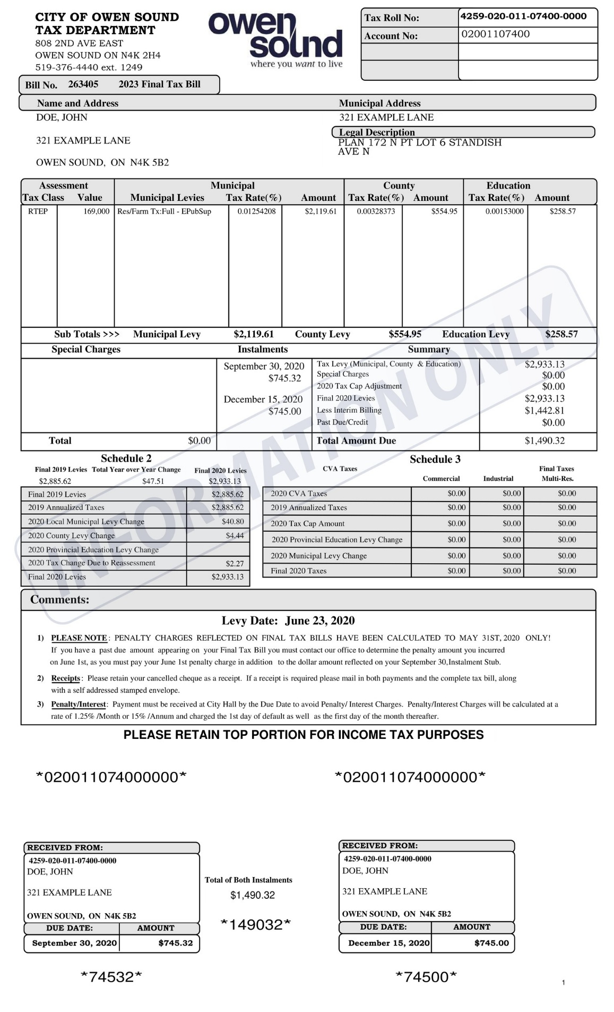
Sample Government-Issued ID and
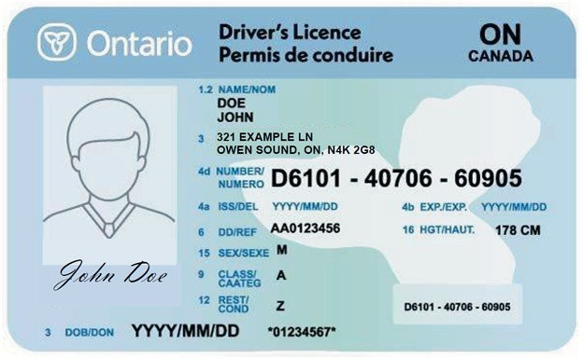
Sample Proof of Primary Residence

Sample Photo of Front of STR
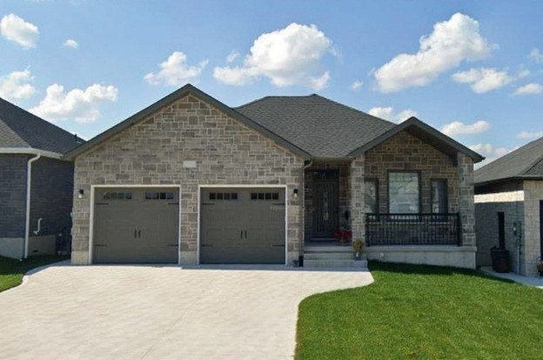
Sample Site Plan
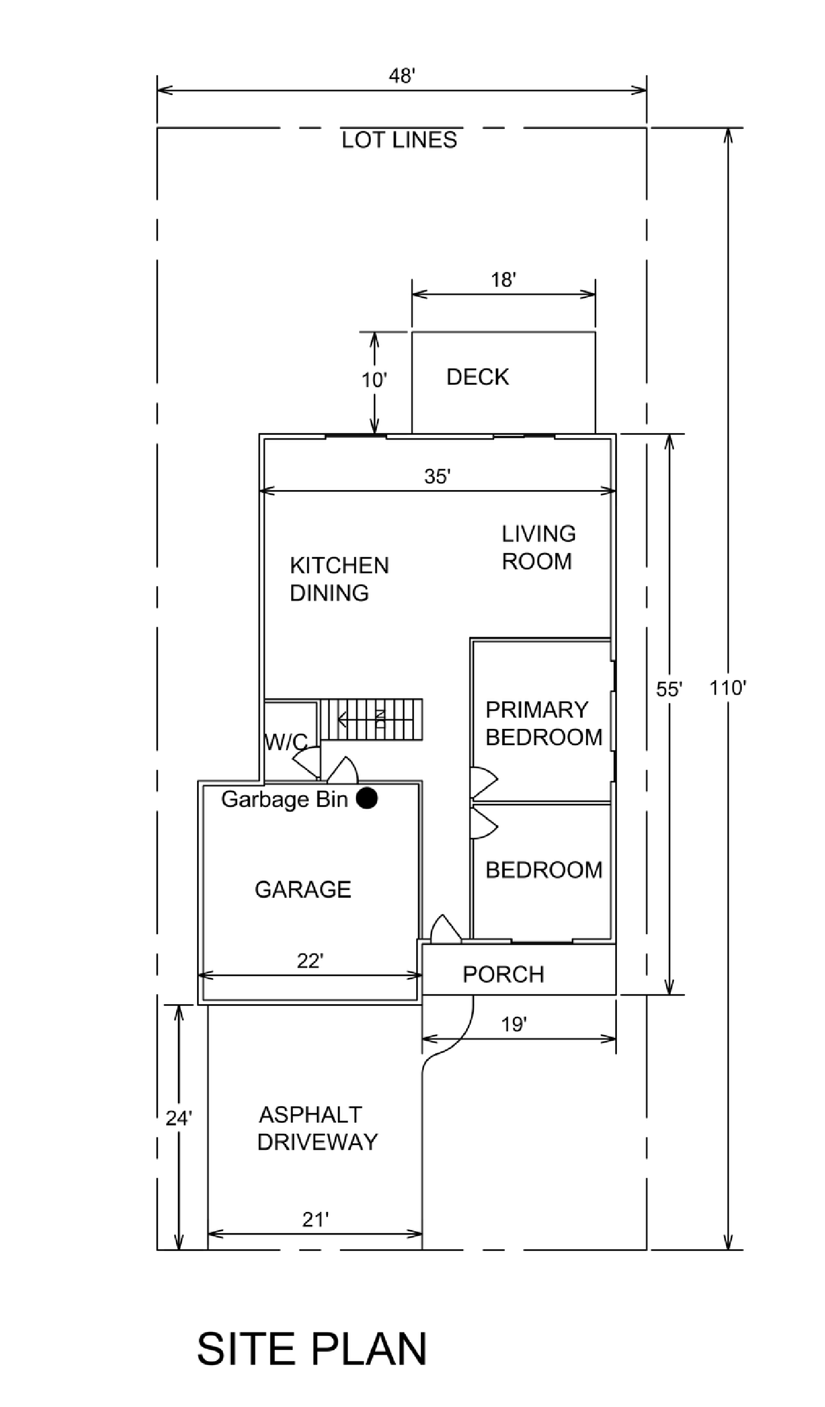
Sample Parking Management Plan

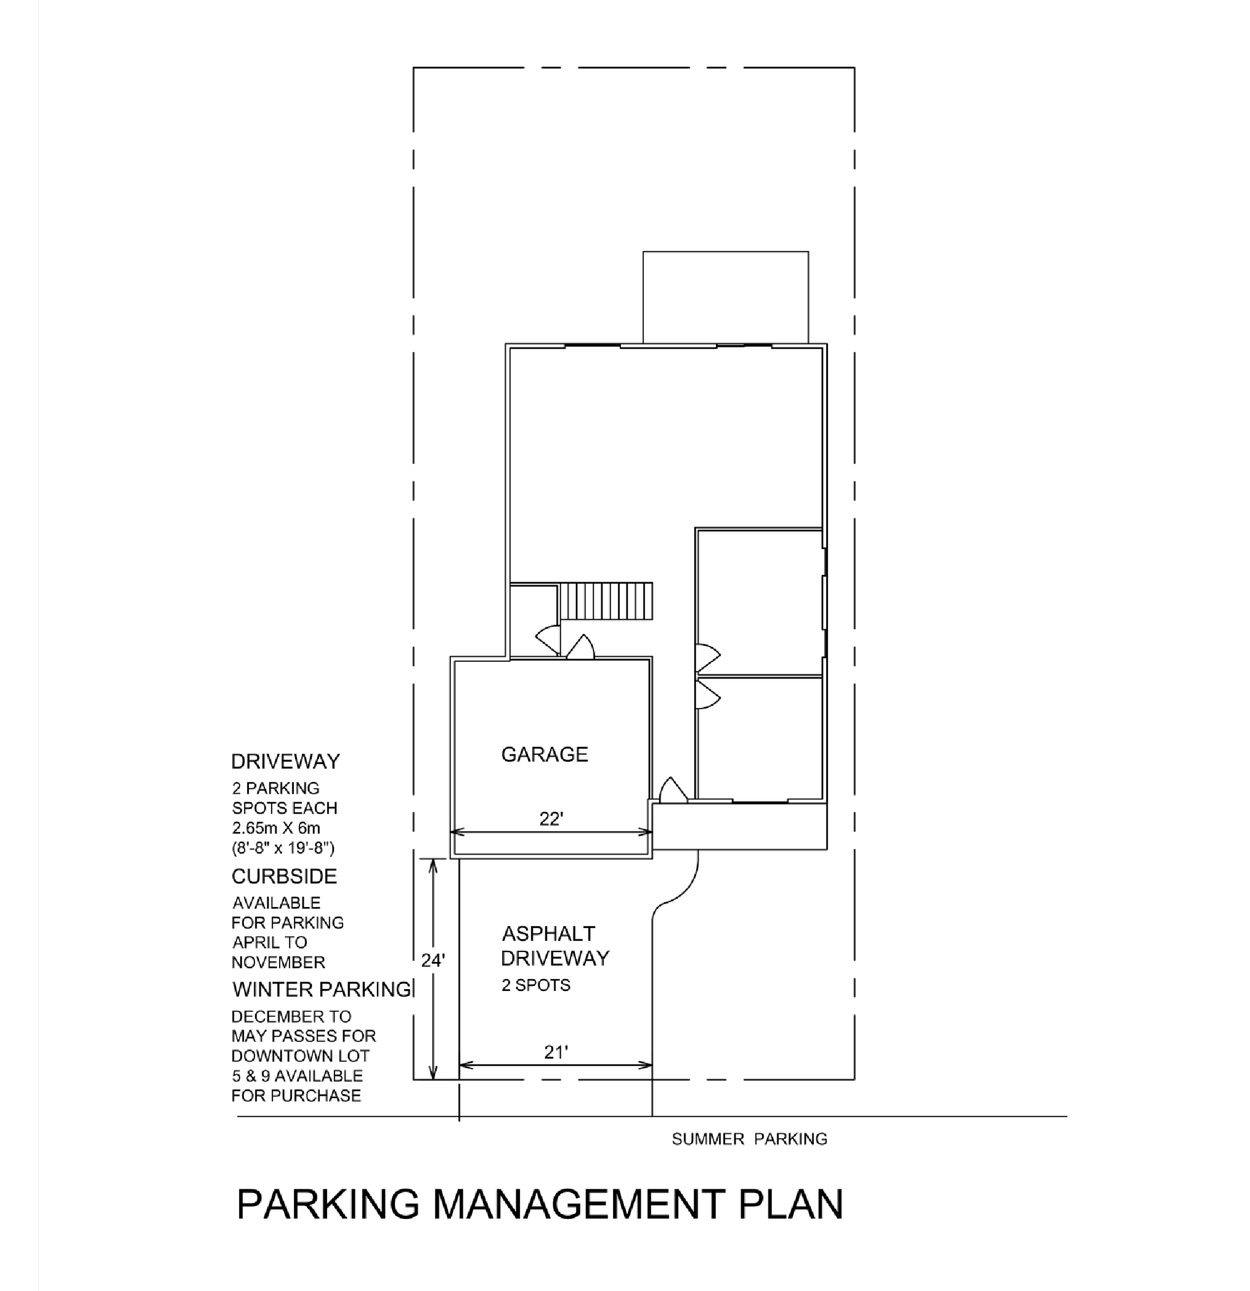

Sample Fire Safety Plan
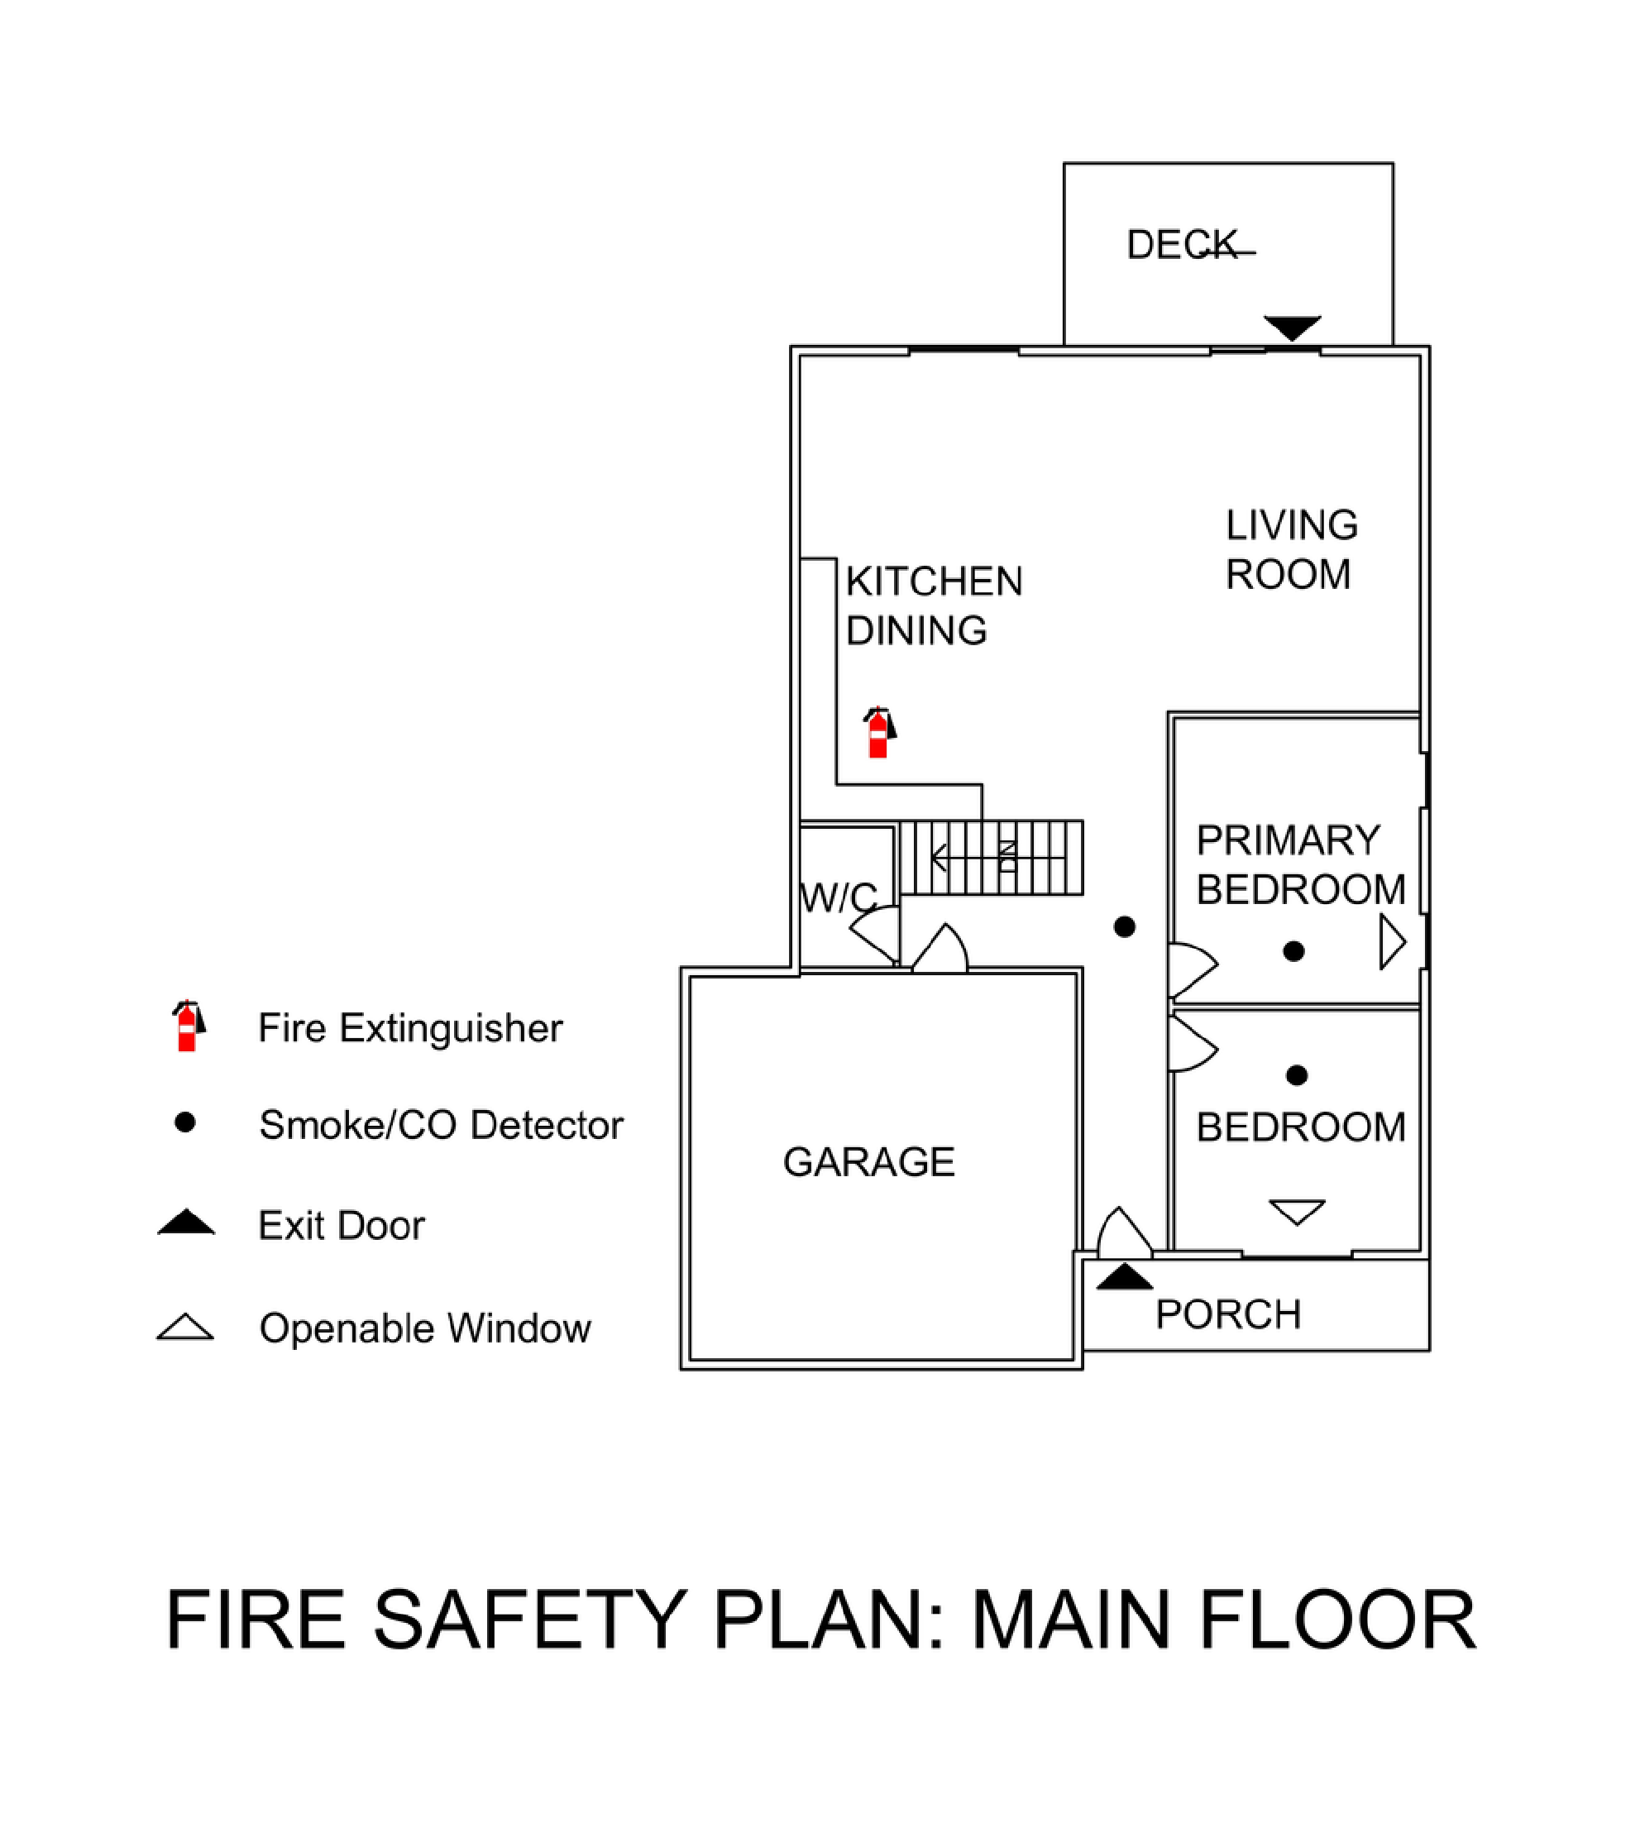

Sample Fire Safety Plan
(continued)
