Advertisement & Sponsorship Program

Municipality of South Huron

Table of Contents
Community Benefit of Advertisings and Sponsorships 3
General Information 3
Advertising Opportunities 4
Arenas 4
Dressing Rooms Advertisement 4
Rink Boards Advertisement 4
Wall Advertisement 8
SHRC Spectator Stair Risers 11
Ice Resurfacer Advertisement 11
In-Ice Advertisement 12
Behind the Bench Advertisement 16
Naming Rights - Outdoor Sport Surfaces 16
Naming Rights - Community Halls 17
Dog Park Panels 18
Recreational Program Sponsorship 19
Public Skating 19
Public Swimming 20
Community Asset Sponsorship 20
Commemorative/Sponsorship Bench 20
Commemorative Tree 22
Public Fundraising for Future Municipal Assets 24
Sponsorship and Advertising Agreements 25

Advertising in South Huron’s recreation facilities or sponsoring a recreational program offers direct access to a highly engaged audience including local families, athletes, and visitors.
With steady traffic from sporting events, public programs, and community gatherings, your business, community group or member will gain consistent, targeted exposure in a family-friendly environment. It’s a cost-effective way to increase visibility, build local recognition, leave a legacy, and demonstrate your support for community well-being and development.

Community Benefit of Advertisings and Sponsorships
When you advertise with or sponsor a Municipality of South Huron program, you're not just promoting your business, you’re investing in your community.
Revenue from advertising and sponsorships supports:
- Keeping costs low for participants;
- Facility and community space enhancements; and
- Recreational and social programming enhancements.
With your support, we’re creating a healthier, more connected, and stronger South Huron.

General Information
- All available advertising and sponsorship opportunities will be advertised on the Municipality’s website.
- All advertising and sponsorship opportunities will be assigned on a first come, first serve basis once confirmation and payment for opportunity has been received.
- All advertising spaces will be assigned based on the next best available location (specific locations of advertisements may not be accommodated). Staff can advise of the specific location available during inquiry phase.
- All materials for advertising must meet the specifications listed and be approved by the Municipality. If the material does not adhere to the specifications, the signage will not be installed.
- If advertisement materials are deemed to be in poor condition (chipped/cracked) or pose a health and safety risk to users of the facility, the Municipality has the right to remove the item and request a replacement from the advertiser. Replacement of advertisement materials is at the cost of the advertiser.

Advertising Opportunities

Arenas

Dressing Rooms Advertisement
Promote your business where the action happens! Advertising on arena dressing room doors offers prime visibility to players, coaches, and families. With steady foot traffic during hockey games, figure skating, tournaments, and community events, your message will reach a wide and engaged audience.
Specifications
Dressing Room Advertisement | Details
Location | Company name will be used when assigning dressing rooms and logo will appear at the entrance of the dressing room above the kick plate.
Available advertising spaces | - South Huron Recreation Centre (6 dressing rooms)  - Stephen Arena (6 dressing rooms)
Duration | 3-year agreement
Cost for space | As outlined in the Fees and Charges Bylaw
Cost for print signage | Design and supply of the dressing room advertisement is the responsibility of the sponsor and must be approved by the Municipality.
Specifications | Size: 40” H x 25” W  Material: 3mm ACM
Annual Deadline | August 15th

Rink Boards Advertisement
Put your brand front and centre with arena ice board advertisement! Positioned at ice level, these high-visibility spots capture the attention of players, spectators, and visitors during games, practices, tournaments, and special events. With consistent exposure to both local residents and out-of-town guests, ice board ads are an impactful way to keep your business top of mind all season long.
Rink Board Advertisement | Details
Location | Company name/logo will be installed on the rink boards, visible from the spectator seating both in the lobby and arena, covered with a protective Lexan material.
Available advertising spaces | - South Huron Recreation Centre (25 spaces)  - Stephen Arena (25 spaces)  See Figure 1 for approved rink board advertising spaces.
Duration | 1-year agreement
Cost for rink board advertisement | As outlined in the Fees and Charges Bylaw
Cost for design and printing | Design and supply of the rink board advertisement is the responsibility of the sponsor and must be approved by the Municipality.
Specifications | - Size: 33” H x 95.875" W  - Material: .040 white polystyrene
Annual Deadline | August 15th

Figure 1
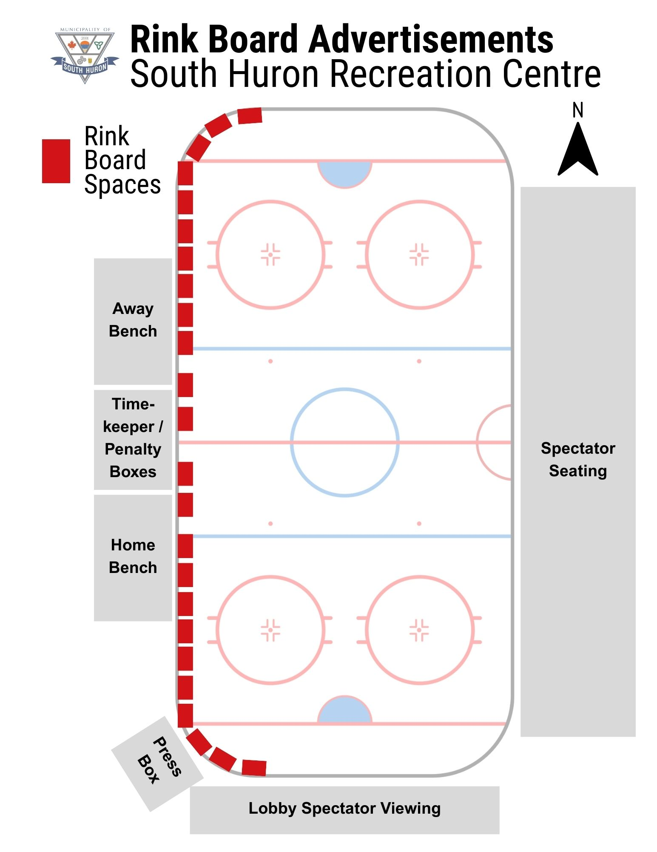
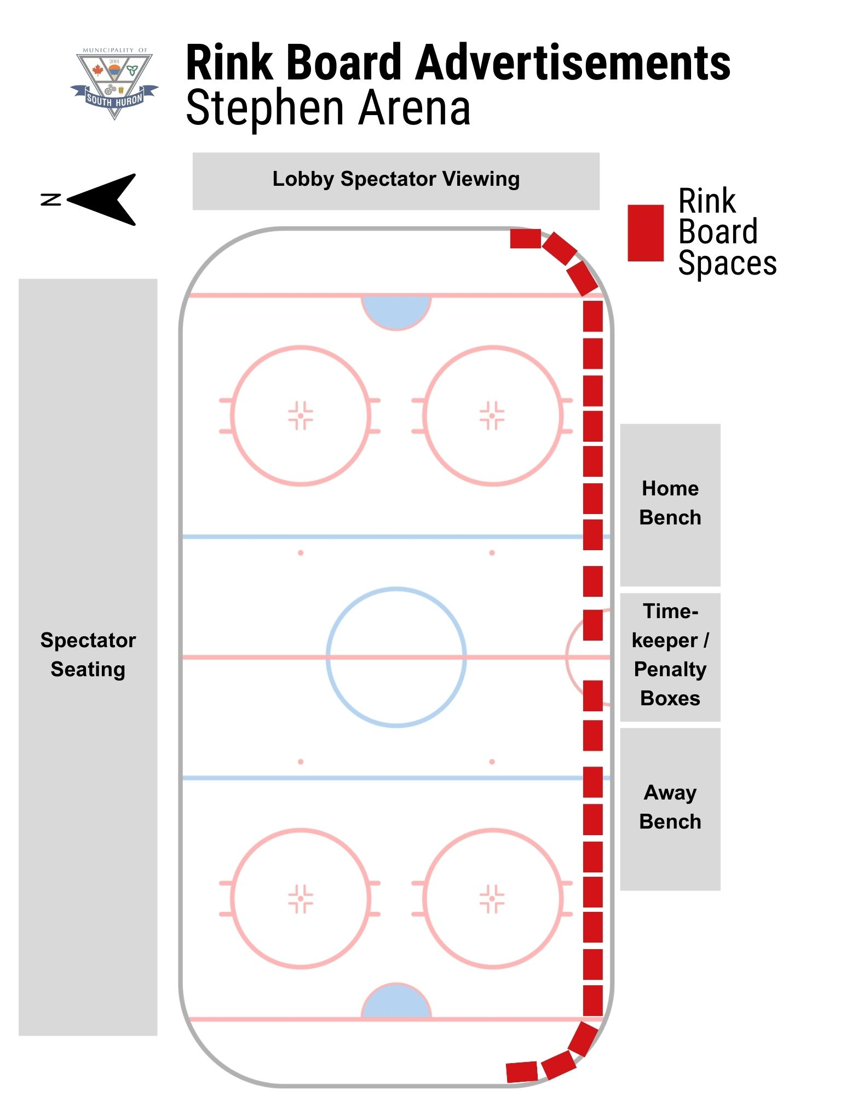

Wall Advertisement
These prominent spaces, behind the player’s benches, offer excellent visibility in high-traffic areas such as lobbies, hallways, and viewing zones. Wall ads provide lasting exposure to players, families, and spectators, making them a powerful and affordable way to promote your business to both local and visiting audiences.
Wall Advertisement | Details
Location | Company name/logo will be installed on the wall behind the players benches.
Available advertising spaces | - South Huron Recreation Centre (41 spaces)  - Stephen Arena (24 spaces)  See Figure 2 for approved wall advertising spaces.
Duration | 1-year agreement
Cost for wall advertisement | As outlined in the Fees and Charges Bylaw
Cost for design and printing | Design and supply of the wall advertisement is the responsibility of the sponsor and must be approved by the Municipality.
Specifications | - Size: 24” H x 96” W  - Material: Coroplast
Annual Deadline | August 15th

Figure 2
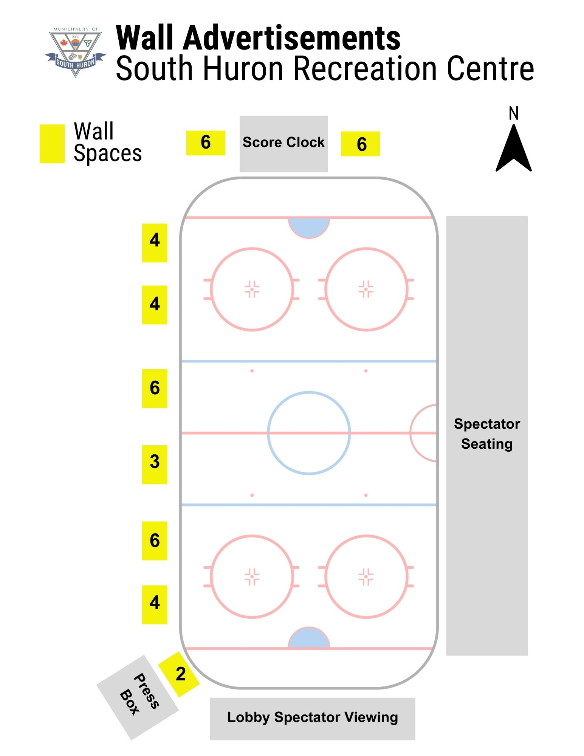

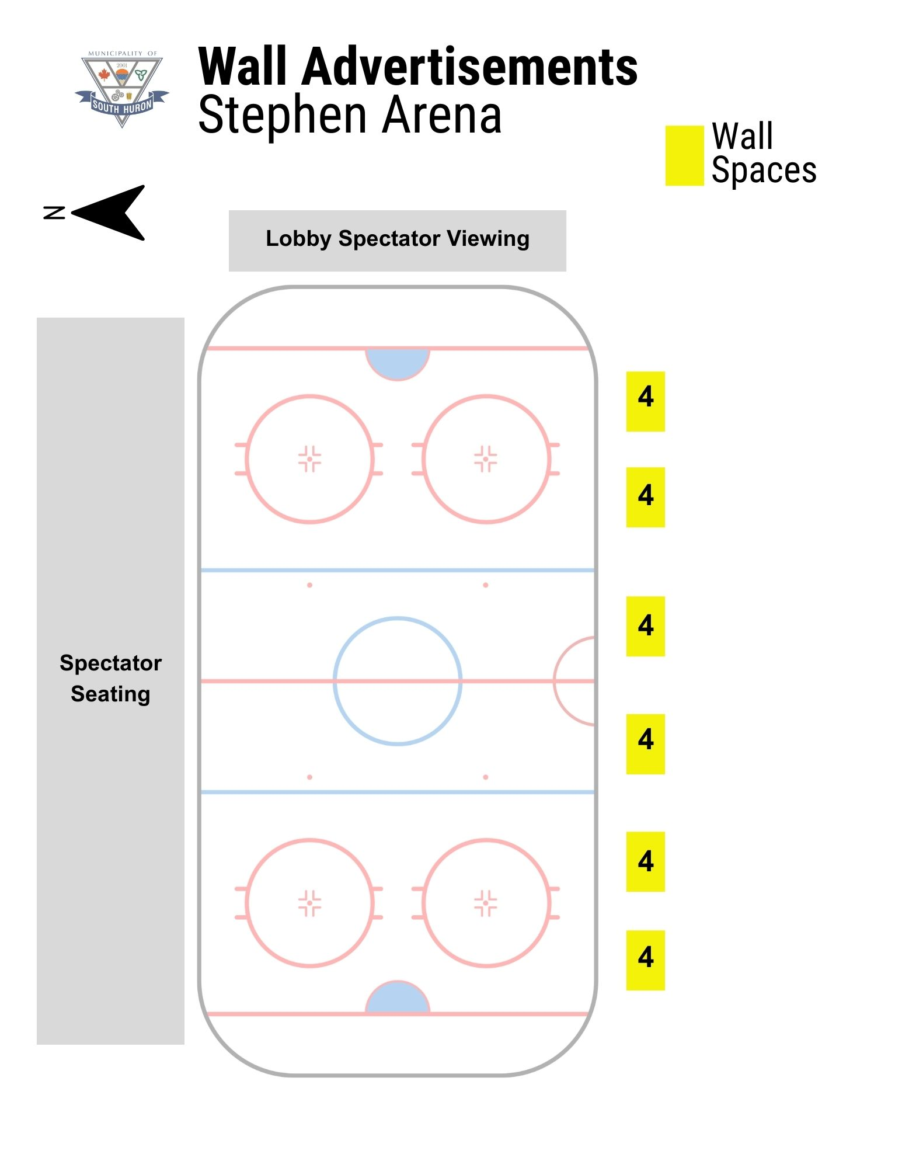

SHRC Spectator Stair Risers
These highly visible spaces, located on the steps within the spectator stands, offer excellent exposure in areas where foot traffic and audience attention are naturally focused. Step ads are seen by fans and families throughout games and events, ensuring your brand remains front and center during every moment of the action. This unique and affordable advertising option provides lasting visibility to both local and visiting spectators.
Spectator Stair Risers | Details
Location | Company name/logo will be installed on front of the stair risers (steps) leading up the stands at the SHRC
Available advertising spaces | - South Huron Recreation Centre (14 spaces)
Duration | 2-year agreement
Cost for front of stair risers | As outlined in the Fees and Charges Bylaw
Cost for design and printing | Design and supply of the wall advertisement is the responsibility of the sponsor and must be approved by the Municipality.
Specifications | - Size: 5” H X 24” W  - Material: 040 white polystyrene
Annual Deadline | August 15th

Ice Resurfacer Advertisement
As one of the most visible elements on the ice, the resurfacer captures attention every time it rolls out — before games, during intermissions, and at tournaments. It’s a unique, high-impact way to showcase your brand to a captive audience of players, fans, and visitors throughout the season.
Ice Resurfacer Advertisements | Details
Location | Company name/logo will be installed on the ice resurfacer.
Available advertising spaces | - South Huron Recreation Centre (1 space)  - Stephen Arena (1 space)
Duration | 3-year agreement
Cost for ice resurfacer advertisement | As outlined in the Fees and Charges Bylaw
Cost for design and printing | Design and supply of the vinyl advertisement is the responsibility of the sponsor and must be approved by the Municipality.
Specifications | Vinyl Wrap
Annual Deadline | August 15th

In-Ice Advertisement
Embedded directly into the playing surface, your logo is front and centre during every game, practice, and event. This premium placement ensures continuous visibility to players, fans, and visitors, offering a bold and memorable way to promote your brand all season long.
In-Ice Advertisement | Details
Location | Company name/logo will be installed within the ice surface
Available advertising spaces | - South Huron Recreation Centre (6 spaces)  - Stephen Arena (8 spaces)  See Figure 3 for approved in-ice advertisement spaces
Duration | 1-year agreement
Cost for in-ice advertisement | As outlined in the Fees and Charges Bylaw
Cost for design and printing | Design and supply of the in-ice logo is the responsibility of the sponsor and must be approved by the Municipality.
Specifications | - Size: dependent on the location  - Material: Jet Ice Easy-In Textile
Annual Deadline | August 15th

Figure 3

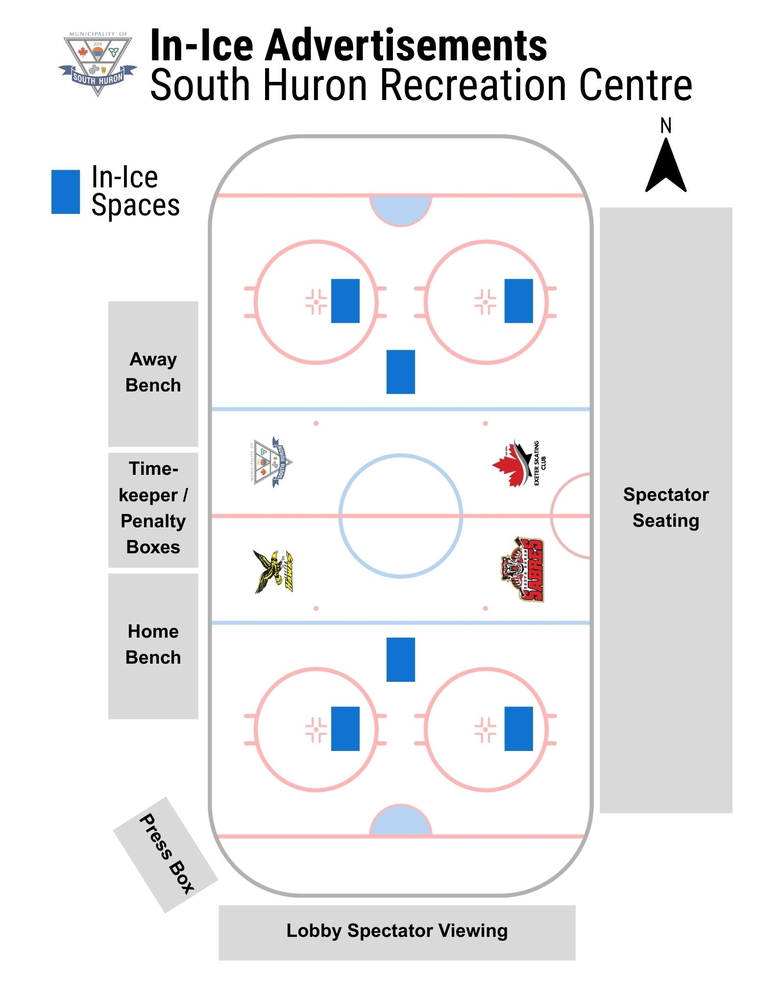
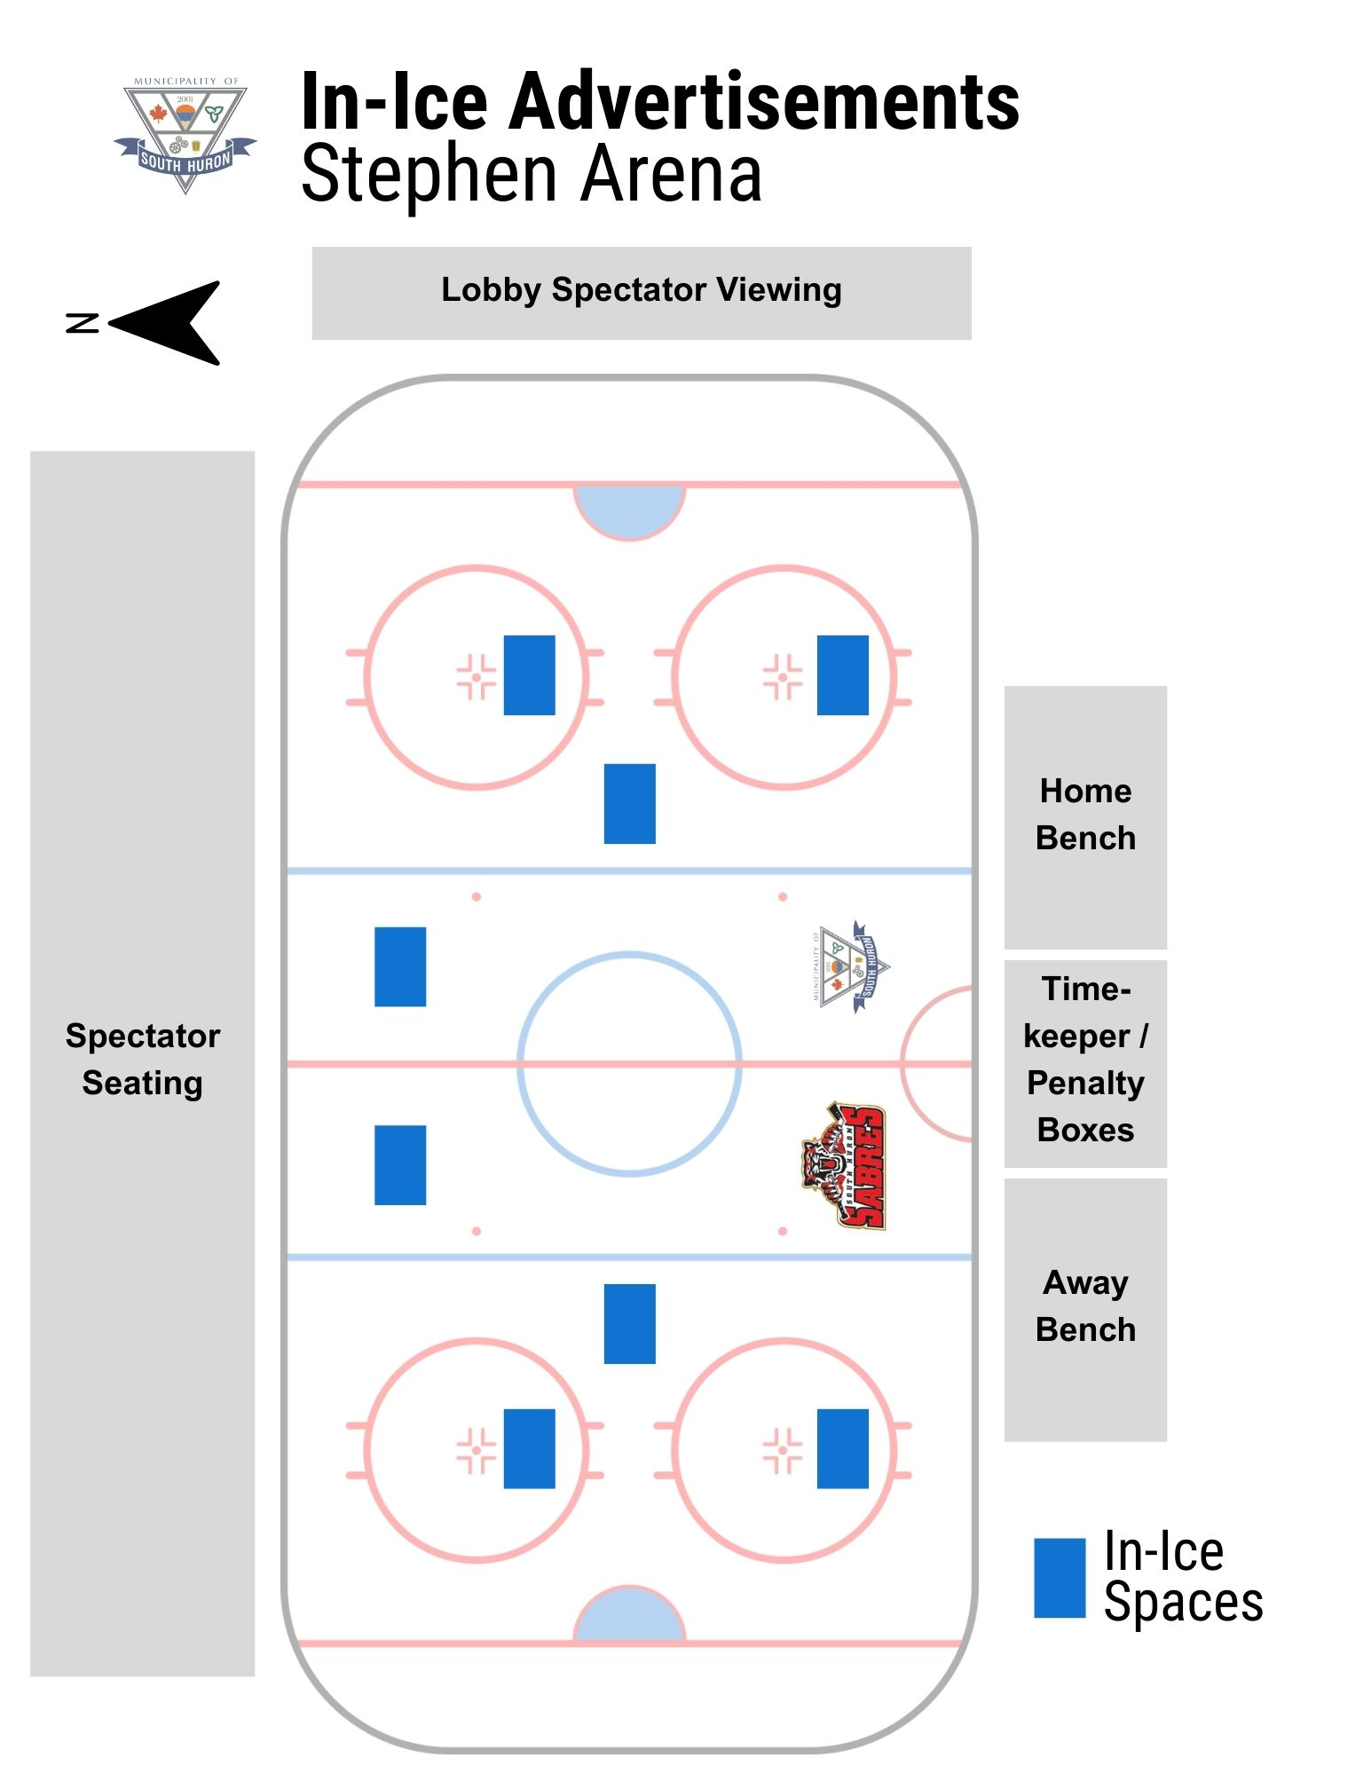

Behind the Bench Advertisement
Show your support and gain visibility by sponsoring the home hockey bench. Your brand will be prominently displayed where the action happens, offering great exposure to players, coaches, and fans throughout the season.
Behind the Bench | Details
Location | Company name/logo will be installed on the back wall/glass of the bench area.
Available advertising spaces | - South Huron Recreation Centre (1 space)  - Stephen Arena (1 space)
Duration | 3-year agreement
Cost for bench advertisement | As outlined in the Fees and Charges Bylaw
Cost for design and printing | Design and supply of home bench advertisement logo is the responsibility of the sponsor and must be approved by the Municipality.
Specifications | Size: 11ft x 4ft
Annual Deadline | August 15th

Naming Rights - Outdoor Sport Surfaces
Naming rights are the highest level of sponsorship, giving an organization the chance to name a Municipal space and gain strong public exposure. This opportunity will include signage at the location, mentions in Municipal communications, and listing on the Municipal website and booking system.
Naming Rights | Details
Location | This opportunity will include signage at the location, mentions in Municipal communications, and listing on the Municipal website and booking system
Available advertising spaces | - SHRC Baseball Diamond 1  - SHRC Baseball Diamond 2  - Crediton Baseball Diamond 1  - Multipurpose Sport Courts  - Community Soccer Field
Duration | 3-year agreement
Cost for outdoor sport surfaces | As outlined in the Fees and Charges Bylaw
Cost for design and printing | Design and supply of the Aluminum Composite Panel is the responsibility of the sponsor and must be approved by the Municipality.
Specifications | Size: 4ft by 8ft  Material: single sided, Aluminum Composite Panel
Annual Deadline | February 1st

Naming Rights - Community Halls
Naming Rights | Details
Location | This opportunity will include signage at the entrance of the hall, mentions in Municipal communications, and listing on the Municipal website and booking system
Available advertising spaces | - SHRC Community Hall  - Dashwood Community Hall  - Crediton Community Hall
Duration | 3-year agreement
Cost for community hall name | As outlined in the Fees and Charges Bylaw
Cost for design and printing | Design and supply of the lettering for the company name is the responsibility of the sponsor and must be approved by the Municipality.
Specifications | Font: Arial  Colour: Black  Size: Dependent on the location  Material: Cut vinyl
Annual Deadline | February 1st

Dog Park Panels
Sponsoring a panel at the local dog park offers your business a unique and powerful opportunity to connect directly with a loyal and engaged audience of pet owners and community-minded residents. Your advertisement will receive lasting, repeated exposure as visitors return to the park regularly—often daily—with their dogs.
Dog Park | Details
Location | Advertisements will be installed on the interior fence surrounding the dog park.
Available advertising spaces | - Crediton Dog Park (16 spots)  - Centralia Dog Park (30 spots)
Duration | 1-year agreement
Cost for dog park panel | As outlined in the Fees and Charges Bylaw
Cost for design and printing | Design and supply of the advertising board is the responsibility of the sponsor and must be approved by the Municipality.
Specifications | Size: 6ft by 3ft  Material: single sided, Aluminum Composite Panel
Annual Deadline | February 1st

Recreational Program Sponsorship

Public Skating
Sponsoring public skating offers your business a unique and high-visibility opportunity to connect with local families, youth, and community members in an active, welcoming environment. Your sponsorship will receive consistent, repeated exposure as residents return to the arena week after week to skate, socialize, and enjoy recreational programming. This partnership positions your business as a supporter of healthy lifestyles and community well-being.
Public Skating Days | Details
Location | This sponsorship comes with promotion on the Municipal website, and on social media platforms.
Available advertising spaces | Public Skate Days are typically held on the following days:  SHRC: Tuesdays, Thursdays and Sundays throughout the winter season  Stephen: Mondays and Wednesdays throughout the winter season  Additional public skates are held over the holiday season
Duration | 1 timeslot
Cost for Skating timeslot | As outlined in the Fees and Charges Bylaw
Additional Opportunity | Sponsor the skate aids at one or both arenas and gain ongoing visibility during public skates.  SHRC: 18 skate aids  Stephen Arena. 9 skate aids
Duration | 1 season
Cost for Skate Aids | As outlined in the Fees and Charges Bylaw
Cost for design and printing | Design and supply of the vinyl sticker is the responsibility of the sponsor and must be approved by the Municipality.
Specifications | Size: 11” x 8”  Material: vinyl sticker
Annual Deadline | August 15th

Public Swimming
Sponsoring a swim at the Exeter Pool provides your business with a highly visible opportunity to connect with local pool users in a fun, active, and community-focused setting. This sponsorship will highlight your business’s commitment to healthy living, water safety, and community well-being.
Public Swimming | Details
Location | This sponsorship comes with promotion on the Municipal website, and on social media platforms.
Available advertising spaces | Public Swims are typically held during the following times during the summer season:  Weekdays: 1:00pm-3:00pm and 6:00pm-7:30pm  Weekends: 4:00-6:00pm
Duration | 1 timeslot
Cost for swimming timeslot | As outlined in the Fees and Charges Bylaw
Annual Deadline | June 1st

Community Asset Sponsorship

Commemorative/Sponsorship Bench
The Commemorative/Sponsorship Bench Program offers a meaningful way to honour a loved one, mark a special occasion, or increase visibility for a community group or business, all while enhancing the beauty and enjoyment of our parks and public places.
There are numerous parks and open spaces owned by the Municipality of South Huron that may be suitable for bench placement. All proposed locations are:
- Located on municipally owned lands;
- Not impeding paths of travel;
- Don’t interfere with general maintenance or use of the space.
Locations
Preapproved bench locations are located in the following areas:
- Exeter Cemetery
- McNaughton Park
- Motz Park
- Victoria Park
- SHRC Playground
- Dashwood Playground
- Crediton Playground
- Centralia Playground
Municipal staff will provide a site layout showing the preapproved locations for the benches when contacted.
Maintenance
All benches installed through the program are the property of the Municipality.
Best efforts will be made to repair a bench or plaque within the Municipality’s standard maintenance coverage/ability (ex, removing graffiti). In the event of theft or vandalism, replacement of the bench will be at the discretion of the Municipality. Should a bench or plaque be vandalized, damaged, or removed due to theft, and the Municipality is unable to address the repairs the purchaser may request reinstallation at their own expense.
The Municipality reserves the right to remove or relocate a bench if it becomes unsafe, unsightly, or requires relocation due to operational, safety, or site-related circumstances.
Upon expiration of the agreement term, the bench will be removed. The original sponsor will be granted first right of renewal, and staff will make reasonable efforts to contact the sponsor using the information provided at the time of purchase before the site is offered to others. If the agreement concludes or the bench is removed, reasonable efforts will be made to return the plaque to the sponsor.
Specifications
Commemorative Bench | Details
Location | Name/logo will be installed on a plaque in the centre of the backrest on the front facing side of the bench.
Duration | 10 years
Cost of commemorative bench sponsorship | As outlined in the Fees and Charges Bylaw
Cost of commemorative bench | Design and supply of the bench will be completed by the Municipality of South Huron to ensure the bench meets the required specifications and there is a consistent look throughout the Municipality.
Cost for plaque | Specific text displayed on plaque will be the responsibility of the sponsor.  Design and supply of the bench will be completed by the Municipality of South Huron to ensure the bench meets the required specifications.
Specifications | Bench:  - Length: 6 feet  - Material: Composite  Plaque:  - Heavy cast Bronze  - 8" w x 2" h  - Font: Arial  - Font size: at minimum 20 pt  - Plaques for benches may have character maximums at the discretion of the Municipality and/or the supplier.
Application Intake Period | January 1st to January 31st

Commemorative Tree
The Commemorative Tree Program provides a meaningful way to honour a loved one, while enhancing the natural beauty and environmental health of our local parks and public spaces.
There are numerous parks and open spaces owned by the Municipality of South Huron that may be suitable for tree planting. Proposed tree location must be:
- Located on municipally owned lands;
- Not impeding paths of travel;
- Don’t interfere with general maintenance or use of the space.
Locations
Trees can be planted in the following areas:
- Exeter Cemetery
- McNaughton Park
- Victoria Park
- Dashwood Community Centre
- Crediton Community Centre
- Centralia Community Area
- South Huron Recreation Centre
Specific locations within these areas will need to be approved by Municipal staff.
Maintenance
Trees will be planted in the spring when the survival rate is the highest. Municipal staff will plant the tree with stakes and install the plaque beside it.
Staff will ensure the tree is watered for the first summer to help it take root, after the first season Municipal staff will not provide dedicated watering.
Best efforts will be made to repair a plaque within the Municipality’s standard maintenance coverage/ability (ex, removing graffiti). In the event of theft or vandalism, replacement of the plaque will be at the discretion of the Municipality. Should a tree or plaque be vandalized, damaged, or removed due to theft, and the Municipality is unable to address the repairs the purchaser may request reinstallation at their own expense.
Specifications
Commemorative Tree | Details
Location | Plaque will be placed next to the Tree
Duration | Undefined
Cost of Commemorative Tree and Plaque | As outlined in the Fees and Charges Bylaw
Cost of Commemorative Plaque | Design and supply of the plaque will be completed by the Municipality of South Huron to ensure consistency
Tree Order | The tree will be ordered by the Municipality of South Huron through the ABCA.
Specifications | Trees:  Trees can be chosen from a number of native tree species including:  - Sugar Maple  - Red Maple  - Oak Pine  - Black Cherry  - Sycamore  - Spruce  - Tulip Tree  Plaque:  - Heavy cast Bronze with a stake  - 4" w x 6" h  - Font: Arial  - Font size: at minimum 20 pt  - Plaques may have character maximums at the discretion of the Municipality and/or the supplier.
Application Intake Period | January 1st to February 15th

Public Fundraising for Future Municipal Assets
Approved May 6, 2013 resolution: #207-2013
The Public Fundraising for Future Municipal Assets policy ensures that all community-led projects—such as public space upgrades, public art and beautification, addition of inclusive features, community gardens and gathering areas—are carried out through transparent, ethical, and properly approved processes. All fundraising, donations, and project plans must be reviewed with Municipal staff and the CAO before beginning, and Municipal Council must approve the project scope, funding, and any related agreements. Joint or community-funded projects require a formal Partnership Agreement and inclusion in the municipal budget, with all purchases and installations following municipal procurement rules.
As outlined in the policy:
Pre-Consultation Required:
All projects must be discussed with Municipal staff and the CAO before starting any planning, fundraising, or promotion.
Council Approval:
Municipal Council must approve all projects, fundraising initiatives, grants, and installations involving municipal property.
Roles & Responsibilities:
- Community Groups & Individuals: must submit, in writing to the CAO or Department Manager a written proposal detailing the project prior to June 30th, allowing adequate time to review the proposal, seek Council approval, and include in upcoming Budget for consideration
- Department Managers: Ensure documentation, approvals, and compliance.
- Treasurer: Oversees budgeting, donation acceptance, and CRA compliance.
Partnership Agreements:
Required for joint or cost-shared projects; must be approved by Council and reviewed by the CAO before any work begins.
Budgeting & Funding:
Projects must be included in the annual municipal budget; no work can begin until funds are secured.
Ethical & Legal Compliance:
All fundraising and donations must meet ethical, legal, and CRA requirements; non-compliant contributions will be returned.
Procurement:
Only authorized municipal officers may purchase goods or services on behalf of the Municipality, following procurement policy.

Sponsorship and Advertising Agreements
All sponsorships and advertising shall be confirmed in a formal agreement.
Review of Existing Advertising Agreements and Sponsorships
All multi-year sponsorship agreements shall be evaluated annually to determine the continued benefit. The term of all agreements shall not exceed three (3) years, unless a longer duration is stipulated within the agreement itself or specifically authorized by Council.
The Municipality reserves the right to terminate an existing sponsorship or advertising agreement should conditions be deemed to no longer be in the best interests of the Municipality, to be determined at the sole discretion of the Municipality.

Changes to Advertisement & Sponsorship Program:

Any administrative changes that do not materially change the program can be made by the Community Services Manager. All other changes require Council approval.

